Hands-on 7: Engineering High-Performance Web Services

1. Prerequisites
- Environment: Ensure you are in your project folder with go.mod.
- Tools: You will use your web browser or curl (or Postman) to test your API.

2. Why are we doing this?
Most Go code lives on servers. Go’s net/http package allows you to handle thousands of concurrent connections with minimal overhead. Today, we move from CLI tools to REST APIs, the backbone of modern web and mobile applications. You will learn how to listen for requests, route them to functions, and serve data as JSON.

3. Objective
- Launch a production-ready HTTP server.
- Implement custom Multiplexers (Routers).
- Handle different HTTP Verbs (GET for reading, POST for creating).
- Master Middleware patterns (logging, authentication).
- Mini-Project: Build a "Task Management API" (CRUD) to manage a list of to-dos via HTTP.

4. Steps To Follow

Step 1: The Basic Web Server & Routing
Create basic_server.go. We will learn how to map a URL path to a Go function.
package main
import (
"fmt"
"net/http"
)
func homeHandler(w http.ResponseWriter, r *http.Request) {
// w is where we write the response
// r is the incoming request data
fmt.Fprintf(w, "Welcome to the Go Web Server!")
}
func main() {
// 1. Assign a route
http.HandleFunc("/", homeHandler)
// 2. Start the server
fmt.Println("Server starting on :8080...")
err := http.ListenAndServe(":8080", nil)
if err != nil {
fmt.Printf("Server failed: %s\n", err)
}
}

To Test: Run the code, then open http://localhost:8080 in your browser.
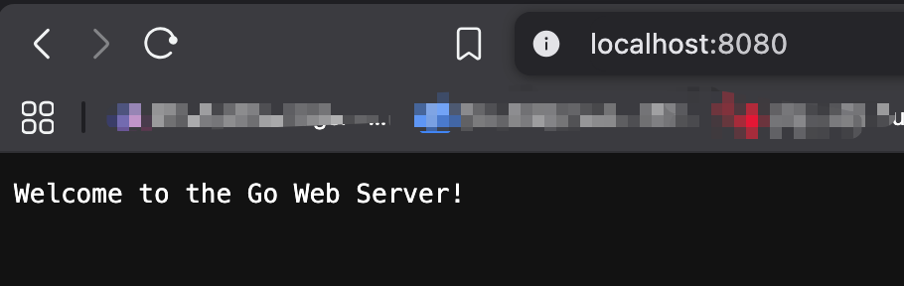

Step 2: Handling JSON & Request Methods
Create api_basics.go. In a real API, we need to check if the user is sending a GET or POST request and respond with JSON.
package main
import (
"encoding/json" // Core package for transforming Go structures into JSON format
"net/http" // High-performance package for handling HTTP/1.1 and HTTP/2
)
// StatusResponse defines the "Shape" of our JSON data.
// The `json:"status"` tags (Struct Tags) tell the Go compiler exactly
// how to name the keys when it exports the data to a web client.
type StatusResponse struct {
Status string `json:"status"`
Version float64 `json:"version"`
}
// statusHandler is a "Handler Function". It must follow a specific signature:
// 'w' (ResponseWriter) is used to send data back to the user.
// 'r' (Request) contains everything coming FROM the user (URL, Headers, Method).
func statusHandler(w http.ResponseWriter, r *http.Request) {
// VALIDATION: We check the HTTP Method. In a REST API, we shouldn't
// allow someone to DELETE or POST to a simple status check.
if r.Method != http.MethodGet {
// http.Error stops the flow and sends a standardized 405 error code.
http.Error(w, "Method not allowed", http.StatusMethodNotAllowed)
return
}
// HEADERS: We tell the browser/client to expect JSON data, not plain text.
w.Header().Set("Content-Type", "application/json")
// INITIALIZATION: Creating an instance of our struct with current data.
resp := StatusResponse{Status: "Running", Version: 1.0}
// STREAMING ENCODER: Instead of creating a temporary string, NewEncoder
// streams the JSON directly to the network connection 'w'.
// This is much faster and uses less memory for high-traffic servers.
json.NewEncoder(w).Encode(resp)
}
func main() {
// ROUTING: We register our path ("/status") and the function that handles it.
// This uses the DefaultServeMux (Multiplexer) built into Go.
http.HandleFunc("/status", statusHandler)
// EXECUTION: Start the server on Port 8080.
// 'nil' tells Go to use the DefaultServeMux we just configured.
// This function is "blocking"--it will keep running until the program is killed.
http.ListenAndServe(":8080", nil)
}

5. Mini-Project: RESTful Task API
Create task_api.go. This is a full-featured mini-service that manages a slice of "Tasks" in memory.
package main
import (
"encoding/json"
"fmt"
"net/http"
"sync"
)
type Task struct {
ID int `json:"id"`
Title string `json:"title"`
Done bool `json:"done"`
}
// In-memory "Database" with a Mutex for thread-safety (from Module 5!)
var (
tasks = []Task{
{ID: 1, Title: "Learn Go Modules", Done: true},
}
mu sync.Mutex
)
func tasksHandler(w http.ResponseWriter, r *http.Request) {
w.Header().Set("Content-Type", "application/json")
switch r.Method {
case http.MethodGet:
// Return all tasks
mu.Lock()
json.NewEncoder(w).Encode(tasks)
mu.Unlock()
case http.MethodPost:
// Add a new task
var newTask Task
if err := json.NewDecoder(r.Body).Decode(&newTask); err != nil {
http.Error(w, err.Error(), http.StatusBadRequest)
return
}
mu.Lock()
newTask.ID = len(tasks) + 1
tasks = append(tasks, newTask)
mu.Unlock()
w.WriteHeader(http.StatusCreated)
json.NewEncoder(w).Encode(newTask)
default:
http.Error(w, "Method not supported", http.StatusMethodNotAllowed)
}
}
func main() {
http.HandleFunc("/tasks", tasksHandler)
fmt.Println("Task API running at http://localhost:8080/tasks")
http.ListenAndServe(":8080", nil)
}

6. Testing Your API
Because this isn't a website, you need to test it using the terminal (or a tool like Postman):
- GET all tasks: curl http://localhost:8080/tasks
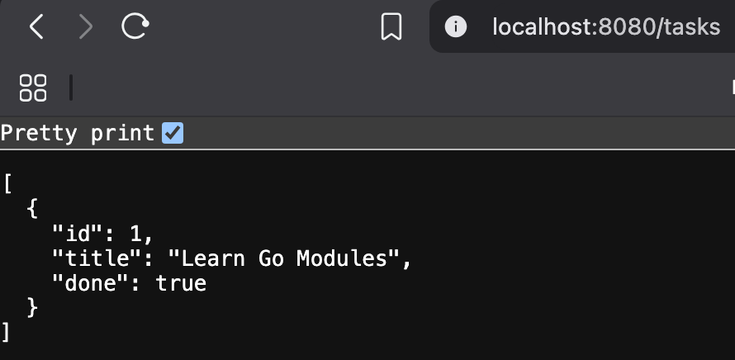
- POST a new task: curl -X POST -d '{"title": "Build a Go Web App"}' http://localhost:8080/tasks
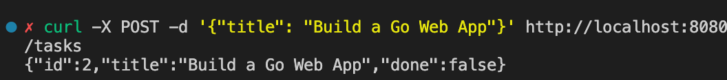
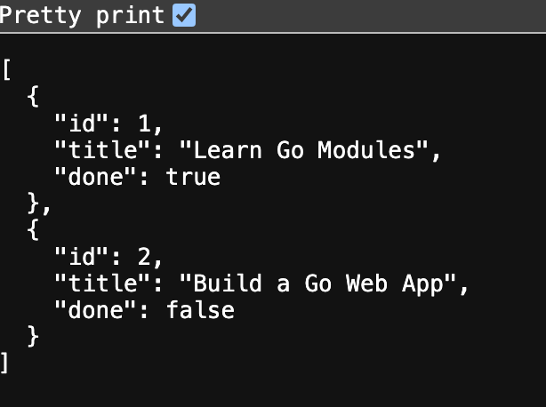

7. Checklist of Accomplishments
- [ ] HTTP Multiplexing: Correctly mapped paths to handlers.
- [ ] Verb Validation: Used r.Method to restrict access.
- [ ] Thread Safety: Used sync.Mutex to prevent data races when multiple users hit the API at once.
- [ ] JSON Interoperability: Used json.NewDecoder and json.NewEncoder for streaming data.
- [ ] Status Codes: Implemented correct HTTP responses (201 Created, 405 Method Not Allowed).

8. Conclusion
You have just built a functional backend. This "Task API" follows the same fundamental patterns as massive APIs used by companies like Stripe or GitHub. You’ve moved from processing local files to serving data globally over the network.

Congrats!
You are now a Go Web Developer. Through this module, you have bridged the gap between local logic and distributed systems. Go’s approach to web services is fundamentally different from frameworks like Django (Python) or Express (Node.js). By utilizing the net/http standard library, you are building on a foundation that is natively multi-threaded and type-safe.

